**Class Practice – 9 (Building layers())**

**MIS 64038**

1, Execute the following commands to build the first layer:

p<-ggplot(mpg, aes(displ, hwy))

p

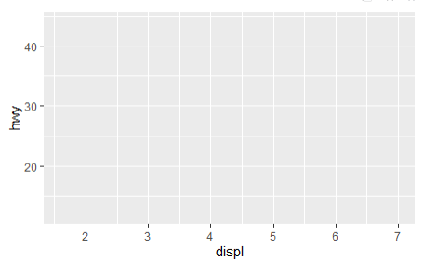

2. Add aesthetics to the plot:

p + layer(

mapping = NULL,

data = NULL,

geom = "point",

stat = "identity",

position = "identity"

)

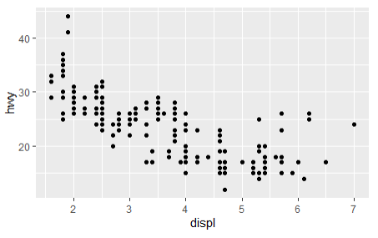

3. Can you change “colour” of points?

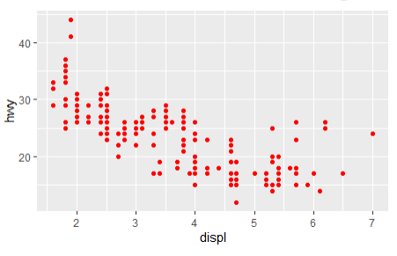

4. Fit the line to the data points by executing following ggplot() program:

ggplot(mpg, aes(displ, hwy, colour = class)) +

geom_point() +

geom_smooth(method = "lm", se = FALSE) +

theme(legend.position = "none")

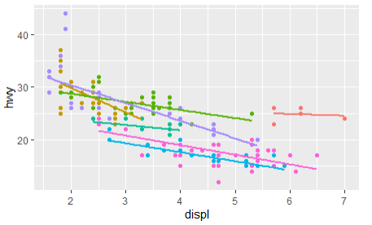

ggplot(mpg, aes(displ, hwy)) +

geom_point(aes(colour = class)) +

geom_smooth(method = "lm", se = FALSE) +

theme(legend.position = "none")

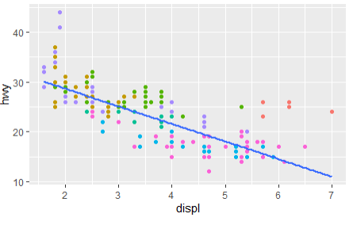

4. Add two different type of line “methods” by executing following program:

ggplot(mpg, aes(displ, hwy)) +

geom_point() +

geom_smooth(aes(colour = "loess"), method = "loess", se = FALSE) +

geom_smooth(aes(colour = "lm"), method = "lm", se = FALSE) +

labs(colour = "Method")

